Datasets Used.



Joining the datasets (Inner Join) by order Id

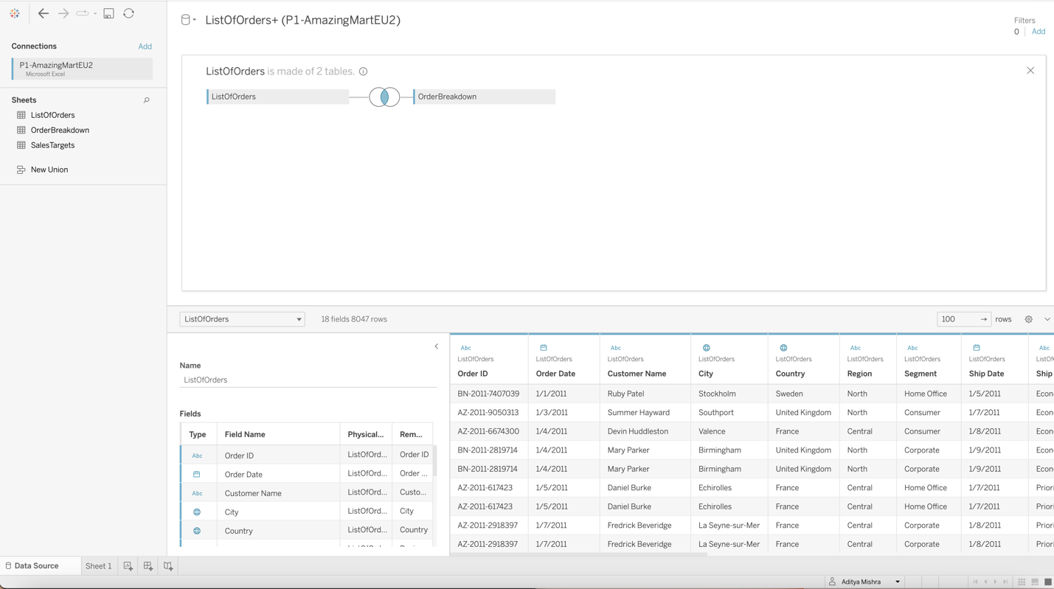

Dataset granulated by state

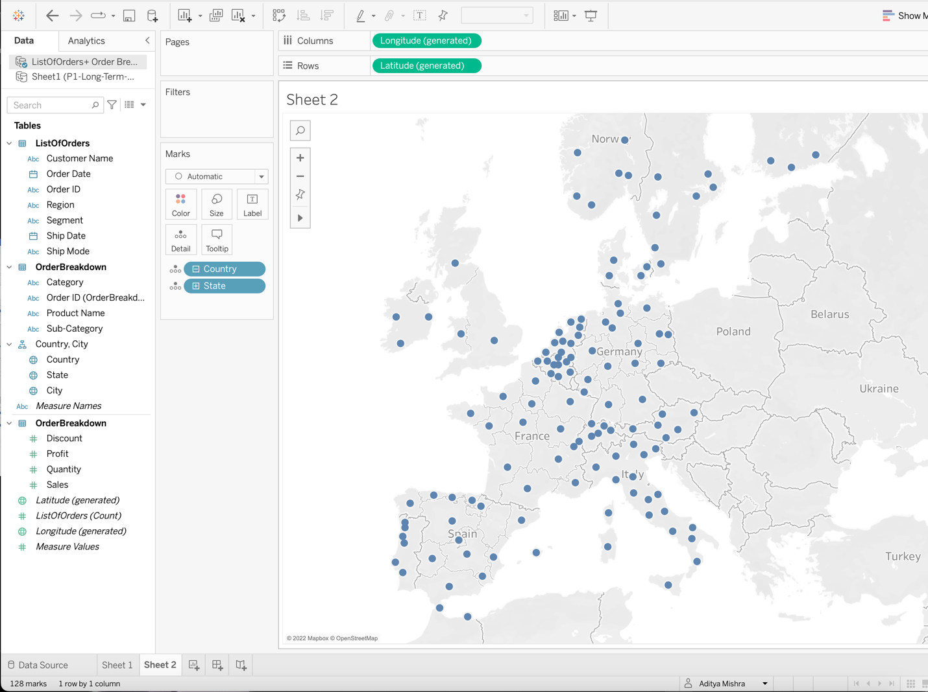

Dataset Granulated by city.

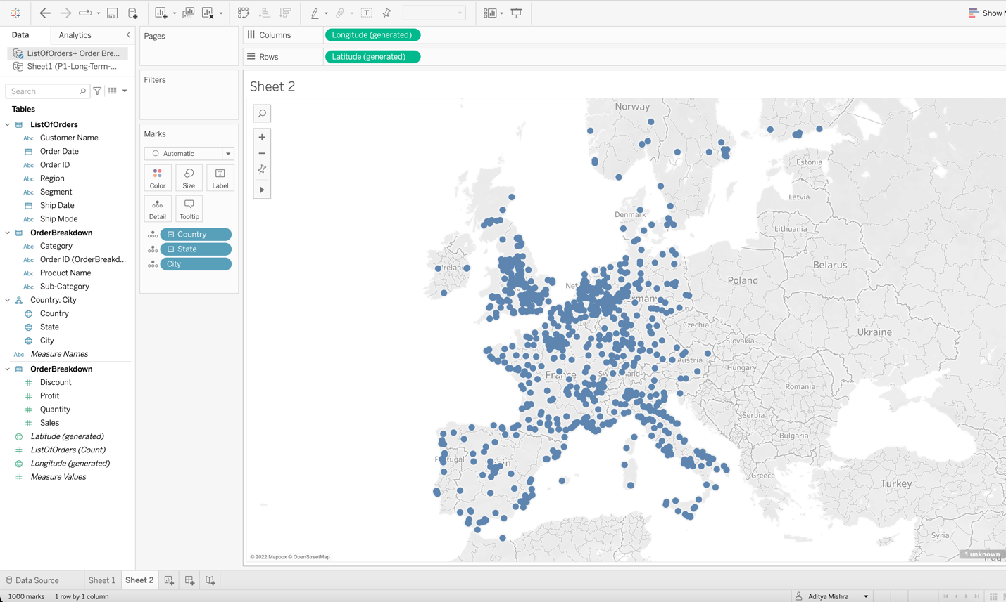

Sum of sales represented by state of each European country

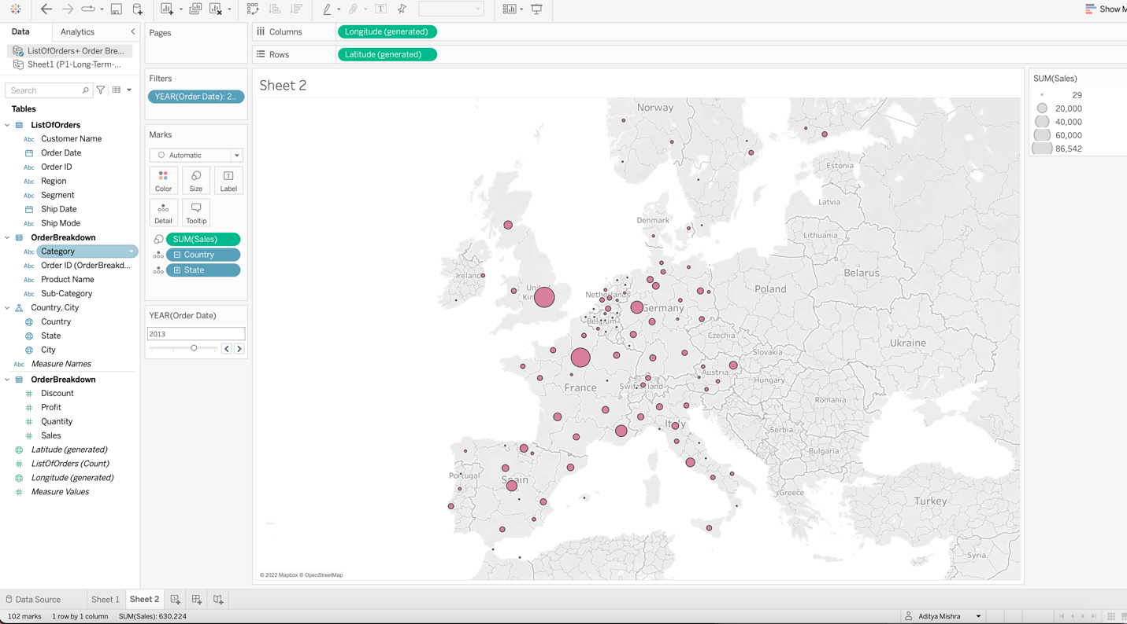

Sum of sales represented by state of each European country with profit margings.

Blue represents profit and red represents loss.

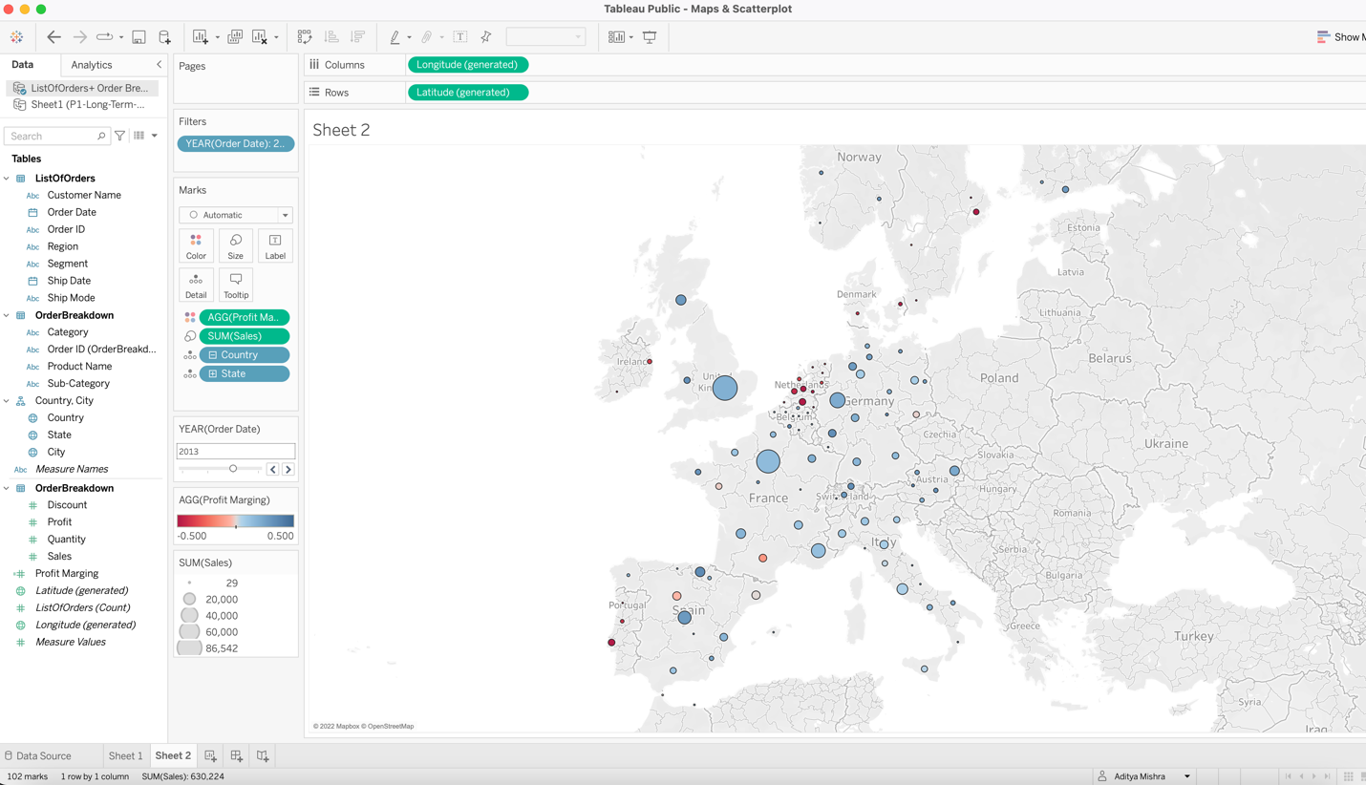

Customer scatter plot

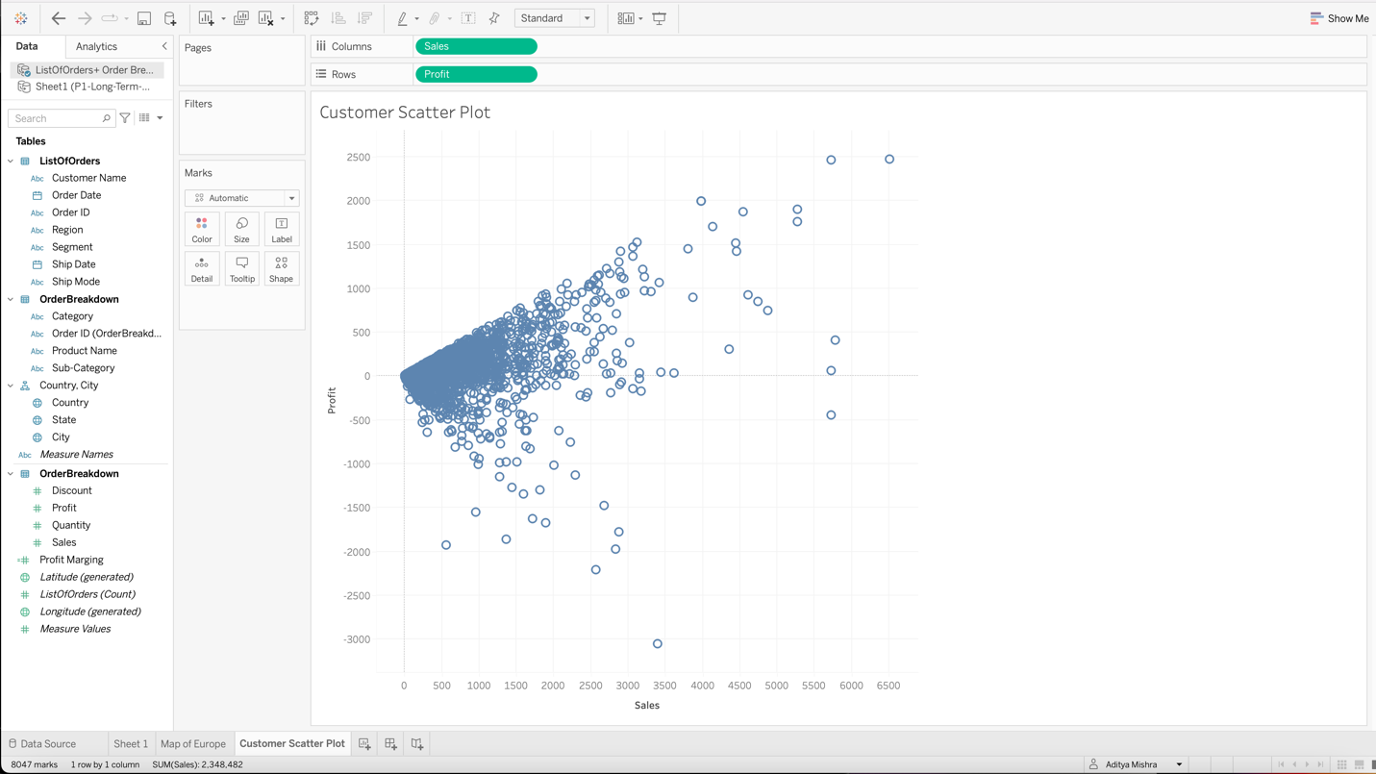

Customer scatter plot by year

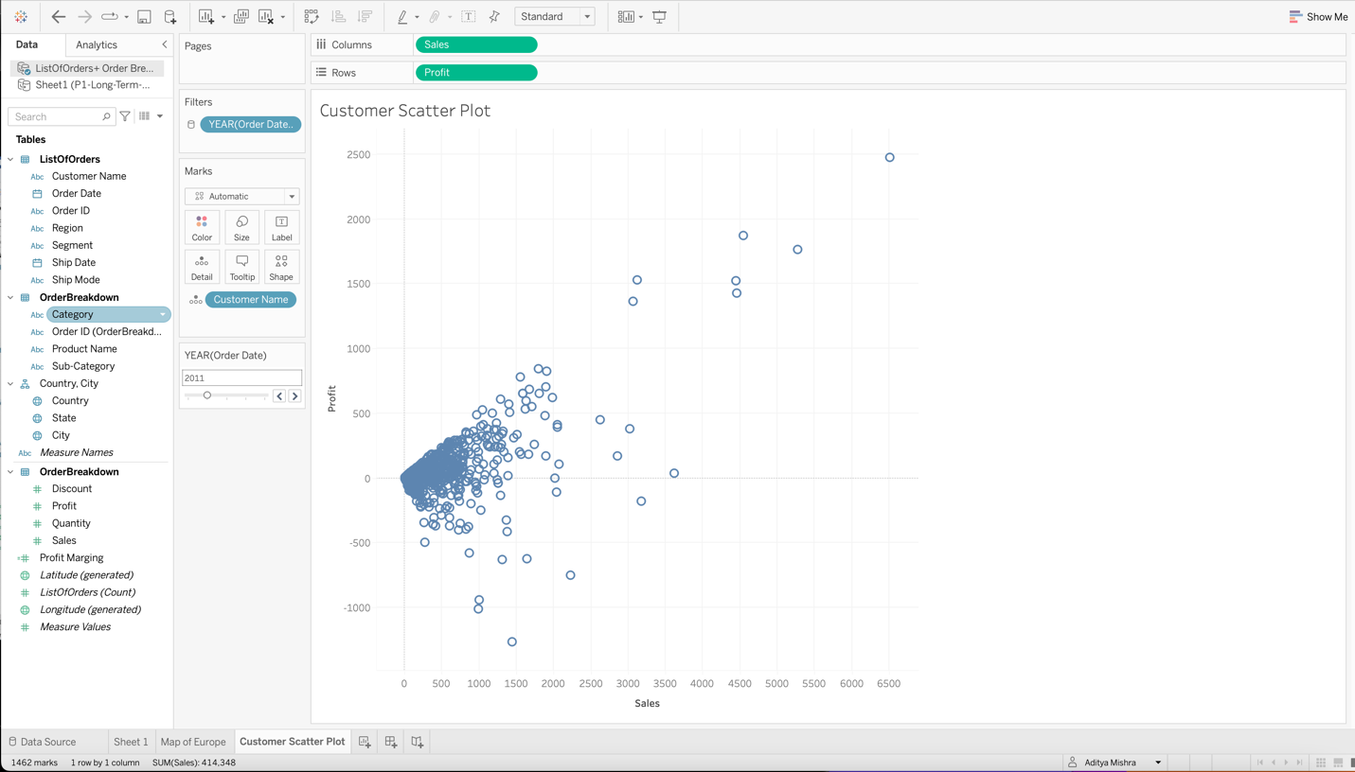

Customer scatter plot by year with emphasized color and customer name.

Creating a Dashboard

Using automatic action to indicate sales based on a region on country’s map and scatter plot.

Sales Bases on actions(not automatic) by a state.

Using ctrl+select to include as many region as needed.

